**User manual**

**Step 1:**  
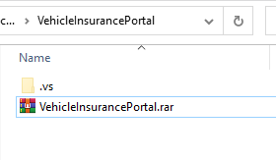

Download Vehicle Insurance Portal winrar  
 Or Clone Vehicle Insurance Portal (<https://github.com/ngan-ng/eProject-VehicleInsurancePortal.git>) to your computer.

**Step 2:**  
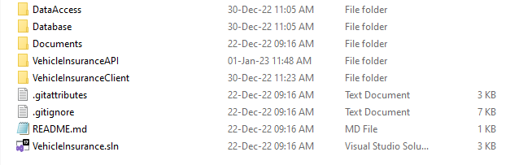

Extract this winrar then you get VehicleInsurancePortal and

then extract to get VehicleInsurance.sln

**Step 3:**

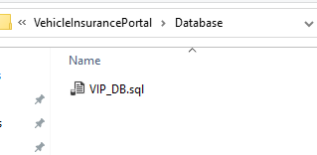  
  
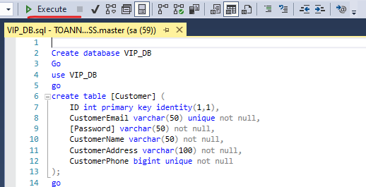

Open VIP_DB.sql in Database Folder and execute it.

**Step 4:**



Close Sql, open VehicleInsurance.sln

**Step 5:**

Choose Multiple startup project in solution’s Properties (Alt+Enter) then click Start to run the project

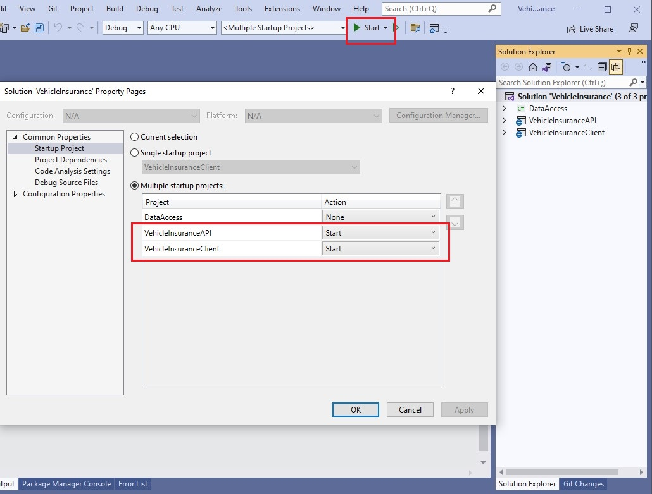

**Step 6:**

Enjoy!!

